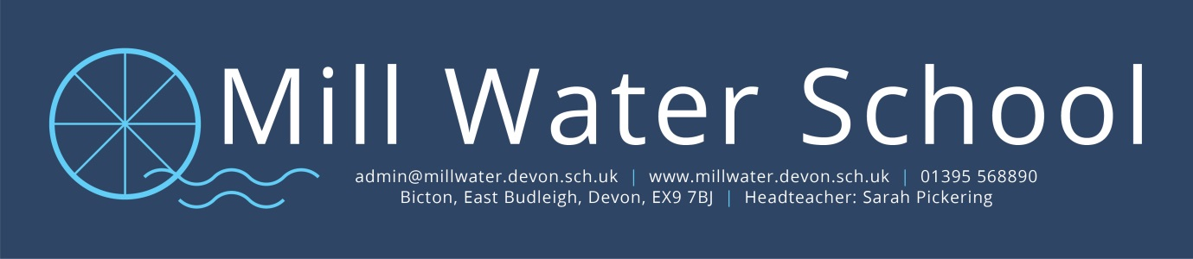

5th January 2021

Dear Parents/Carers,
The last few days have been particularly challenging for us in trying to prepare for the return of pupils. This was made even more challenging yesterday with the announcement of the new national lockdown from tomorrow. I had to ask you to keep your child at home today to give us time to plan and prepare and I am very grateful for your support.
Following the Prime Minister’s address last night, it is clear our school must remain open for the most vulnerable pupils and children of keyworkers. In order to do this safely, knowing that “schools may nonetheless act as vectors for transmission, causing the virus to spread between households”, we must reduce numbers in each class at any one time.
Today you will have been contacted by your class teacher and will know what the next few weeks looks like for child in terms of school attendance or home learning, and we ask for your understanding and support around this. It may be necessary to change plans at short notice if we do not have sufficient staff available.
Safety is the number one priority for the school and has guided all our decision making throughout this pandemic. Our home learning offer will help to reduce risk as much as possible during these uncertain times and importantly, provide a level of stability in your child’s education.
As ever, I am available to talk to you and offer whatever support and signposting you might need.
Yours sincerely
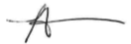
S A Pickering

